Key point list
name: class:
- States of matter
Features | volume | fluidity | shape
solid
liquid
gas

- Kinetic particle theory
Features | arrangement | distance | movement
solid
liquid
gas

- Change of states

solid liquid gas

solid gas

Boiling point:
Melting point:

Extension :If the substance is impure
the melting point will increase , the boiling point will decrease

- Diffusion
Particles move from a region of concentration towards a region
of concentration, eventually, the concentration is evenly spread.

Rate of diffusion is affected by:1.
2.
Relative molecular mass(Ar) for molecules:
A_{r}(NH₃)= A_{r}(HCl)=

Questions:
- Use the ideas of the Kinetic Theory to explain why, after about an hour, the bromine gas molecules have spread uniformly to occupy the whole container.

- A liquid has a fixed volume but takes up the shape of the container. A gas takes up the shape of the container but it does not have a fixed volume.

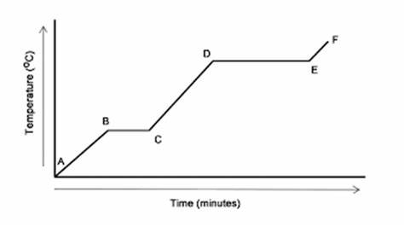
- What happens to the temperature while the substance changes state?

- The graph shows that the substance takes longer to boil than to melt. Suggest a reason for this.

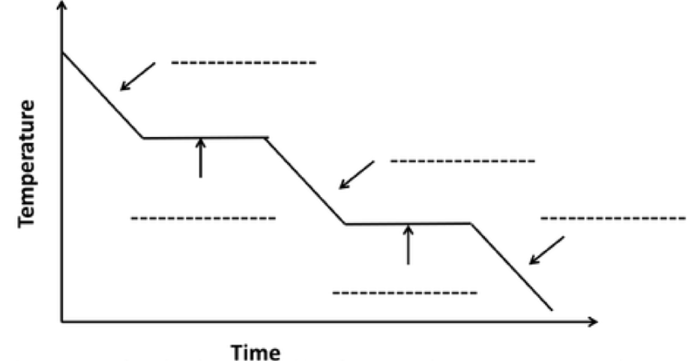
- Explain why the temperature stays steady when changing its state, even though you keep on cooling the container.

